SD-WRT-FLASH User Manual
Document No.: Version: v0.18
Author: Wu Peisi Reviewer: Chen Jibin
Approved by: Date: 2026-05-18

Contents
1. Introduction 3
2. Package Contents 3
3. Hardware Description 3
4. Instructions 6
4.1 Software installation 6
4.2 Burner Connection 7
4.3 Burning procedure 8
4.3.1 Chip selection 9
4.3.2 Import program file 9
4.3.3 Chip empty check, full erase, burning, verification, read/write protection 11
4.4 Temperature calibration 13
4.5 Erase mode 14
4.6 Read and view buffers 15
4.7 Write 16
4.8 Hardware Reset Enable and Disable 17
4.9 SRAM Test 18
4.10 Factory Account 19
4.11 Configuration File Account 20
4.12 Offline Operation 20
4.13 Custom data burning 27
4.14 View custom data 29
4.15 NVR burning 29
4.16 Offline temperature calibration 33
4.17 Verify burner 34
4.18 Empty burner 34
4.19 Hex file encryption 35
4.19.1 Key generation 35
4.19.2 Encryption 36
4.19.3 Decryption 37
4.20 SD82F46X debug port operation 38
4.21 Chip Encryption and Decryption 39
4.22 Voice Files 41
4.23 Live Power Programming 42
4.24 Online User Data Area Programming 43
5. Mass Programmer's Signal 44
6. Error prompt 44
7. FAQ 44
7.1 Driver Installation 44
8. Modified record 45
- Introduction
The SDIC Writer is a program burning tool developed by Hangzhou SDIC Microelectronics Inc. for programming Flash memory chips (OTP not yet supported) from our company. It supports online and offline burning.
- Package Contents
Item | Specification | Qty
Burner host |  | 1
Power Adapter | DC5V Output | 1
USB Cable | USB Host to Device | 1
Burning cable | 2.54mm 8Pin | 1
- Hardware Description
As shown in Figure 3.1. The burner hardware includes a power interface, power module, main MCU, LED display, status indicators, buttons, and burning port. The functions of each part are described as follows:
Power Interface: Dual input (USB / Adapter).
Online: USB power.
Offline: USB or adapter (do not connect both).
Voltage range: 4.75V～12.5V.
Figure 3.1 Diagram of burner

- LED Display: Shows programming status and information.
- Status LEDs:
ERROR: Error indicator.
BUSY: Busy indicator.
POWER: Power indicator.
- Buttons:
START: Trigger offline programming.
BLANK: Interrupt to display user data and enter ready state.
- Programming Port: 8Pin. Connect to the target board via the burning cable. as shown in Figure 3.2.
Figure 3.2 Burning Interface

The burner connects to the target board via a burning cable.
The burning interface of SD93F115, SD93F112 and SD93F115B are shown in Table 3.1.
The burning interface of SD93F302、SD81F233、SD82F35X、SD82F46X are shown in Table 3.2.
The burning interface of SD25FXXX series are shown in Table 3.3.
The burning interface of SD82PX53、SD82F255 are shown in Table 3.4.
The burning interface of SD82F479 data area and voice data area are the same. shown in Table 3.5.
User should connect the burning interface to the corresponding pins of the Flash chip according to the burning pin description in the application manual of different chips.

Table 3.1 Pin Description of Burning Interface (SD93F115, SD93F112, SD93F115B)
PIN | interface | description
1 | BOOT | Connected to BOOT pin of chip
2 | - | reserved
3 | PSDO(T4) | Connected to chip TXD1/TXD/SWCLK pin (SD93F115B connected to SWCLK)
4 | PGND | Connected to target board reference ground
5 | PSDI(T2) | Connected to chip RXD1/RXD/SWDIO pin (SD93F115B to SWDIO)
6 | - | reserved
7 | PVDD | Connected to the target board power
8 | - | reserved

Table 3.2 Burn Interface Pinout (SD93F302, SD81F233, SD82F35X, SD82F46X, SD82F255)
PIN | interface | description
1 | - | reserved
2 | - | reserved
3 | - | reserved
4 | PGND | Connected to target board reference ground
5 | PSDI(T2) | Connected to chip SDA pin
6 | PSCK(T1) | Connected to chip SCL pin
7 | PVDD | Connected target board power
8 | - | reserved

Table 3.3 Burn Interface Pinout (SD25FXXX)
PIN | interface | description
1 | - | reserved
2 | PCLK(T3) | Connected to chip CLK pin
3 | - | reserved
4 | PGND | Connected to target board reference ground
5 | PSDI(T2) | Connected to chip ISP_SDA pin
6 | PSCK(T1) | Connected to chip ISP_SCL pin
7 | PVDD | Connected to target board power
8 | - | reserved

Table 3.4 Burn Interface Pinout (SD82PX53)
PIN | interface | description
1 | - | reserved
2 | - | reserved
3 | - | reserved
4 | PGND | Connected to target board reference ground
5 | PSDI(T2) | Connected to chip ISP_SDA pin
6 | PSCK(T1) | Connected to chip ISP_SCL pin
7 | PVDD | Connected target board power
8 | PVPP(T5) | Chip serial burn high voltage pin

Table 3.5Burn Interface Pinout (SD82F479)
PIN | interface | description
1 | - | reserved
2 | PCLK(T3) | Connected to chip CS pin
3 | PSDO(T4) | Connected to chip ISP_SDO pin
4 | PGND | Connected to target board reference ground
5 | PSDI(T2) | Connected to chip ISP_SDI pin
6 | PSCK(T1) | Connected to chip ISP_SCK pin
7 | PVDD | Connected target board power
8 | - | reserved

- Instructions
  - Software installation
Minimum System Requirements
- CPU: Pentium or higher
- RAM: 512MB
- HDD: 500MB free
- OS: Windows XP / Vista / 7 / 8 / 10 / 11
- Required Component: .NET Framework 2.0
When installing for the first time, please check the option of installing driver. After clicking the option of "Complete", the installer will pop up the driver installation window, as shown in Figure 4.1.1.
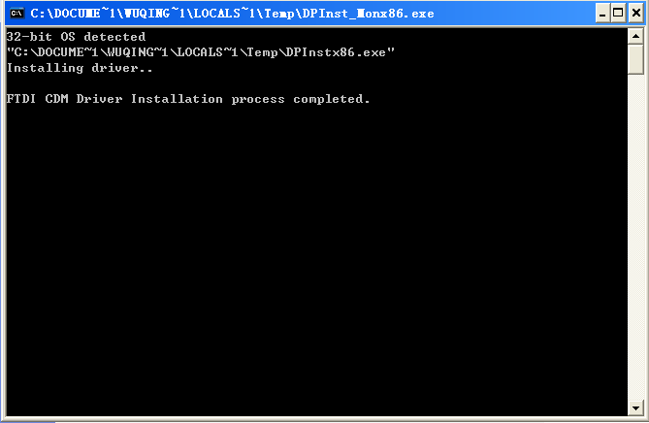
Figure 4.1.1 Driver Installation Window

If unchecked, manual driver installation is required. Users can find the driver named " CDM212364_Setup.exe " under the "Driver" folder in the installation directory, and double-click to complete the installation.
After the driver installation is completed, the computer will prompt the driver installation information when the burner is connected to the computer for the first time. After the detection is completed, the burner can be used normally.
Windows 7 Note: Run installer as Administrator to avoid driver installation errors. as shown in Figure 4.1.2.
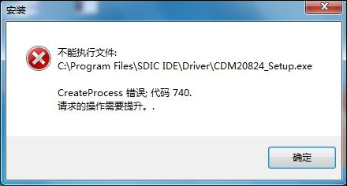
Figure 4.1.2 Installation Error Prompt

  - Burner Connection
Before connecting the burner, the user must ensure that the USB cable, computer and burner are properly connected and the corresponding driver software is installed.
The software will automatically connect the burner when it is turned on. The automatic connection function is turned on by default. The user can turn off this function by clicking the "Auto connection (A)" option in the "Tools" menu.
If the automatic connection fails, the user can also connect through the "Connecting the burner (C)" option in the "Tools" menu. as shown in Figure 4.2.1.
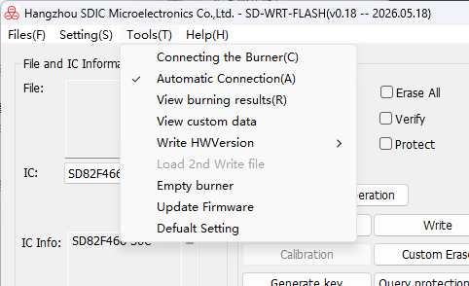
Figure 4.2.1 Burner connection

After successful connection, the connection successful message will be displayed in the Output Information interface.
If multiple connections fail, the user should check whether the burner is in normal working condition, or contact our staff.

  - Burning procedure
Figure 4.3.1 Burning Procedure Flow
    - Chip selection
Click the "IC" option in the "File and IC Information" column and select the required chip model, for example, select SD93F115, as shown in Figure 4.3.2.
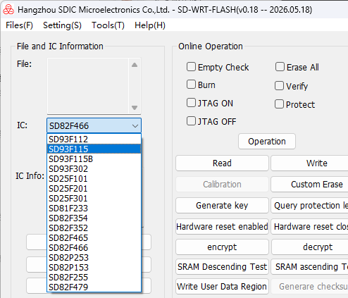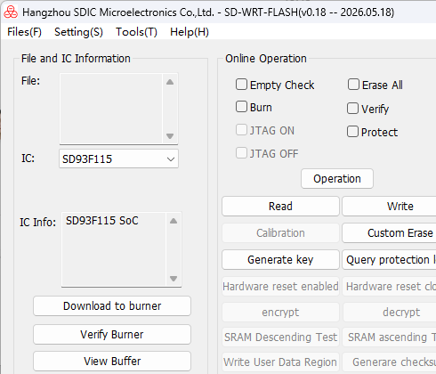
Figure 4.3.2 Select chip model Figure 4.3.3 Chip Information
After selection, the corresponding chip information will be displayed in the information bar. Please select the correct chip model to burn to avoid error or chip damage.

    - Import program file
      - Import local file
As shown in Figure 4.3.4, click "File" in the menu bar, select "Open", and click "Local files" (IHEX/HEX format).
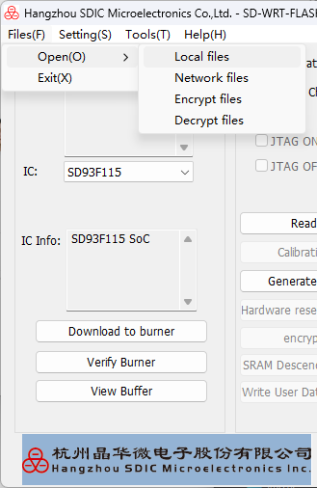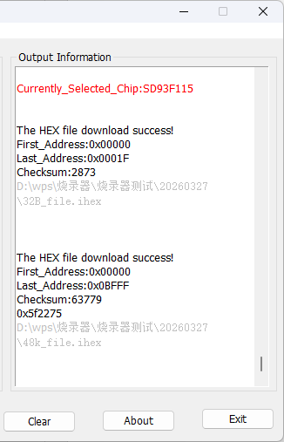
Figure 4.3.4 Import Local Files Figure 4.3.5 Output information interface
Select the file to be imported in the dialog box opened. Note that SD81F233, SD82F35X, SD82PX53, SD82F255 and SD82F479 chips can only import HEX files. Other chips can only import IHEX files. If the file import fails, please confirm whether the burner is normal or the file is correct.
After successfully importing local files, if the HEX/IHEX file is updated, the burner will automatically detect file comparison and import the file into the burner without repeated import by the user.

      - Import network files
Click "File" in the menu bar, select "Open", click "Network files" to pop up the dialog box for opening network file settings as shown in Figure 4.3.6, and fill in user name and password in the dialog box (required information is provided by Hangzhou SDIC Microelectronics Inc.).
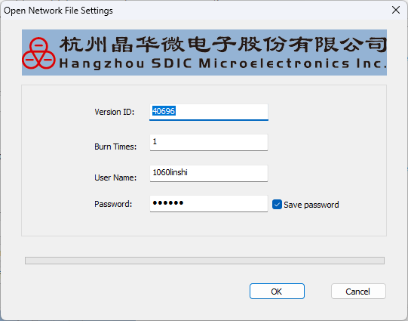
Figure 4.3.6 Network file

After clicking OK and the network file is successfully imported, the dialog box for offline download burner will pop up, as shown in Figure 4.3.7. The burning times and calibration information have been filled in the dialog box, and there is no need to manually input them. Users can set encryption level and custom data as needed, download to the burner and then press the “Start” button to execute operation.

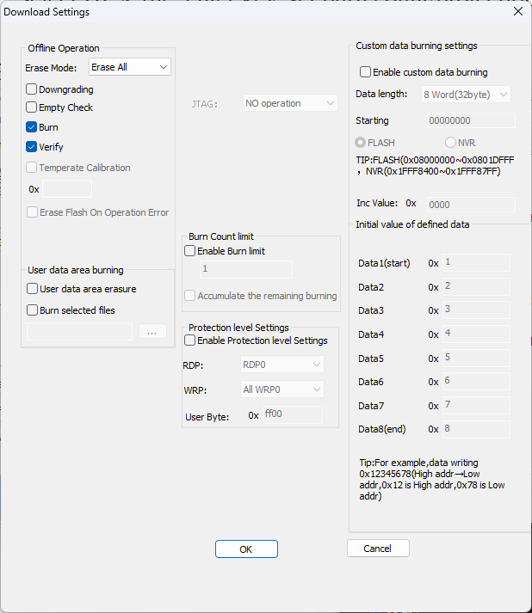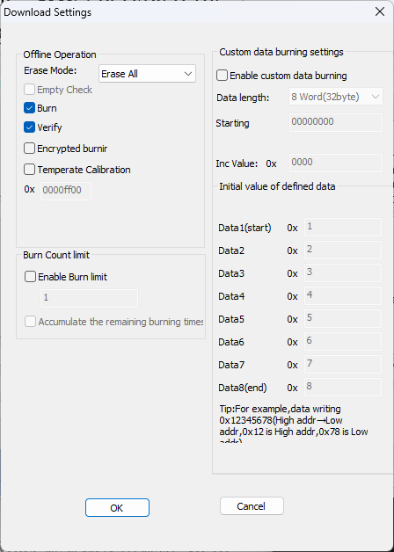
Figure 4.3.7 Import network files Figure 4.3.8 Import network files
(SD93F115B chip) (SD25FXXX series chips)
The network file can only be downloaded once by the burner. To download it again, you must re-import the network file. Local files can be downloaded to the burner unlimited times.

    - Chip empty check, full erase, burning, verification, read/write protection
As shown in Figure 4.3.9, the five functions can be selected simultaneously or separately. After selection, click the "Operation" button at the bottom to start the corresponding operation on Flash. If the operation fails, the operation button and check box of the main interface will prohibit operation (gray). Click the tool option in the menu bar and click "Connecting the Burner", and the main interface will return to normal.
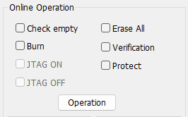
Figure 4.3.9 chip online operation

Empty check: Verifies whether there is data in the user program area of the target chip. If data exists, relevant information will be displayed in the output interface; If no data is found, “the chip is empty” will be shown. When erase all is included and all options are selected, the execution order is: Erase all, Check empty, Burn, Verification, Protect.
Erase all: erase all data in the target chip. It is recommended to select both “Erase all” and “Burn”，so that the chip is erased before burning.
Burn: Write the imported HEX/IHEX file to the target chip
Verification: Reads data from the target chip and compares it byte-by-byte with the imported HEX/IHEX file.
The SD93F112, SD93F115, SD93F115B, SD82F46X, SD82F35X, SD82F255, and SD82F479 series support protection level configuration, as shown in Figure 4.3.10. For SD93F302 and SD81F233, protection level settings are shown in Figure 4.3.11.
Write protection levels include Write Protect 0 and Write Protect 1; read protection levels include Read Protect Level 0, Read Protect Level 1, and Read Protect Level 2. For detailed descriptions of read/write protection levels for different chip models, refer to the respective chip application manuals.
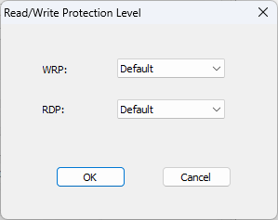
Figure 4.3.10 SD93F112、SD93F115、SD82F46X、SD93F115B、SD82F35X、SD82F255、SD82F479 protection level configuration

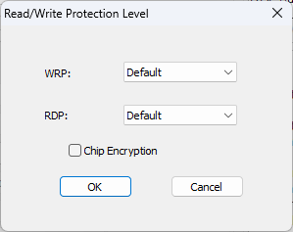
Figure 4.3.11 SD93F302、SD81F233 protection level configuration

The write protection level supports custom selection. Taking SD93F115B as an example, there are 30 blocks, each representing a 4 KB user program area, as shown in Figure 4.3.12. Check the corresponding block to enable write protection; unchecked blocks remain unprotected. The number of configurable blocks varies by chip model. Refer to the chip user manual for details.
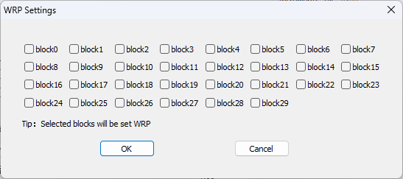
Figure 4.3.12 Write Protection Custom Settings

The protection checkbox for SD25FX01 and SD82PX53 enables encryption. For details, refer to Section 4.20 Chip Encryption and Decryption.

  - Temperature calibration
SD93F112、SD93F115、SD82F255、SD82F479、SD82F46X chips have no temperature calibration function
In-line temperature calibration is shown in Figure 4.4.1. The user can select the temperature calibration address to store the temperature and ADC value.
After clicking calibration, you can select the temperature calibration function, put the temperature calibration address in the hexadecimal edit box, click OK, and the temperature value and ADC value measured by the burner will be stored in the temperature calibration address. The ADC value will be stored in the upper 16 bits of the temperature calibration address, and the temperature value will be stored in the lower 16 bits of the temperature calibration address.
Temperature calibration address selection can select user Flash area and user data area, SD93F302, SD81F233, SD82F35X chips temperature calibration can only be selected in the first user data area,SD93F115B chip temperature calibration can only be selected in the Flash user program area,SD93F112,SD82F466,SD93F115,SD82P253 chips temperature calibration is not available, SD25FXXX series chips temperature calibration selection in Flash user program area, chip user Flash address and user data address Please refer to the chip user manual.
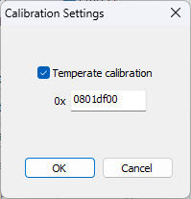
Figure 4.4.1 On-line temperature calibration

  - Erase mode
Chip erase include full erase and custom erase. Custom erase can select sector area to erase, for example, as shown in Figure 4.5.1 of SD93F115B chip, write the sector area number to be erased into the edit box, separated by ","(symbol format in English input state), and continuous sector area erasure can be edited by (). Please note that erasing the user configuration area will change the protection level of the chip. For details, see the chip user manual (chip user configuration area, user data area, user flash area size, see the chip manual for details, subject to the chip manual, NVR area custom erase, erasable NVR area address user configuration area, user data area).
Some chips support individual sector erasure, while others only support full-chip erasure. Refer to the user manual for details.
Note:SD82P153/SD82P253 are OTP chip, and cannot be erased.
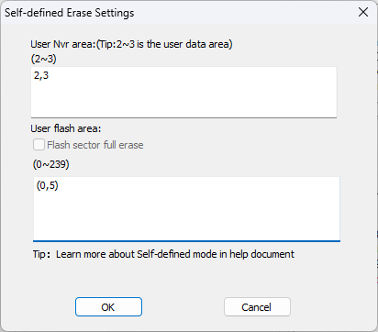
Figure 4.5.1 Custom erase settings
  - Read and view buffers
Read: Reads data from the target chip.
View Buffer: Displays user‑imported data or data read from the target chip in byte or word (4‑byte) format.
Select the chip model and click the Read button on the Online Operation interface. The read settings dialog shown in Figure 4.6.1 will appear. Enter the start address and number of bytes to read (the range must not exceed the chip’s ROM size), then click OK to start reading. Options are provided for the FLASH area and NVR area. If NVR is selected, data from the NVR area will be read, and the range must not exceed the chip’s NVR size (refer to the chip manual for NVR specifications). If neither FLASH nor NVR options are displayed, the chip has no user configuration area or user data area.
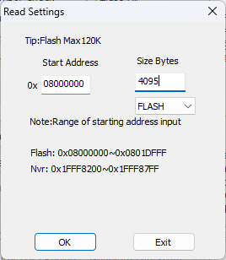
Figure 4.6.1 Data read (SD93F115 chip as an example)
After reading, a dialog box will pop up as shown in Figure 4.6.2 to view the hexadecimal code in Flash.
Click the “View Buffer” button to directly open the dialog box shown in Figure 4.6.2. The imported file data will be compared with the data read from the chip, and inconsistent data will be marked in red. Data can be displayed in either word or byte format.
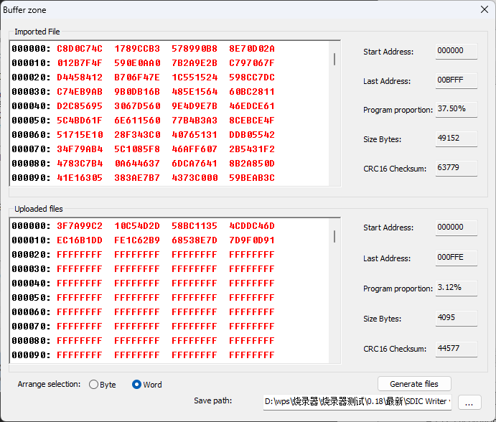
Figure 4.6.2 Data buffer
  - Write
The burner provides a "Write" function, which can burn data of no more than 8 bytes to the specified address and verify the written data. SD82F479 is written in double characters (8 bytes).
Take SD93F115 chip as an example, click the "Write" button on the "Online Operation" interface, and the write data setting dialog box as shown in Figure 4.7.1 will pop up. Select the writing method, enter the address within the address box, enter the data of at least 8 bytes in the data box, and enter the data in the order of high byte first (refer to the chip manual for the address range).
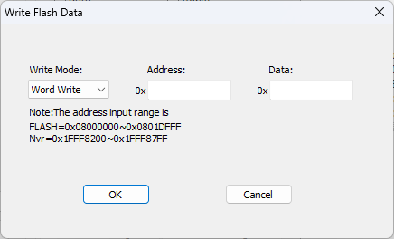
Figure 4.7.1 Write Data (SD93F115 Chip)

Enter the start address and the data to be written in the dialog box (address range cannot exceed the size of chip ROM). There are three writing methods: single-word writing, half-word writing and byte writing. Data is hexadecimal, with high byte of data first. Click OK button to start writing data, burn the set data according to the set writing method (SD93F302, SD82F46X, SD25FXXX, S D81F233 chips can only be written in single character, The SD82F255 chip can only be written in bytes, while the SD82F479 can only be written in 8 bytes, which is 8 bytes.).
The addresses of SD82F46X and SD81F233, SD82F255, SD82F479 chips will be divided into NVR areas. The FLASH user program area address and NVR user data area address of SD82F46X, SD82F255, SD82F479 and SD81F233 chips need to be distinguished by checking the NVR check box. The OTP user program area, NVR user data area and peripheral area of SD82P153/SD82P 253 chips (note: They are OTP chips) need to be distinguished by checking the check box. Other functions remain the same.
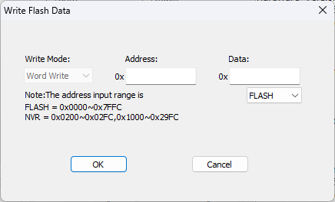
Figure 4.7.2 Write data (SD81F233 chip)

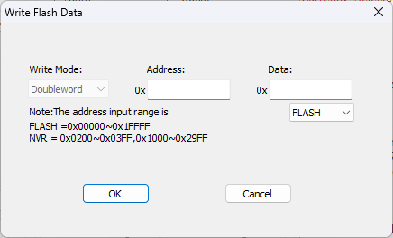
Figure 4.7.3 Write data (SD82F479 chip)

  - Hardware Reset Enable and Disable
The SD82F46X chip supports enabling and disabling hardware reset. Click the corresponding options as shown in Figure 4.8.1 and Figure 4.8.2 to turn hardware reset on or off.
To disable hardware reset successfully, connect pin P45 of the target chip to a high level. This function is designed for live-power programming.
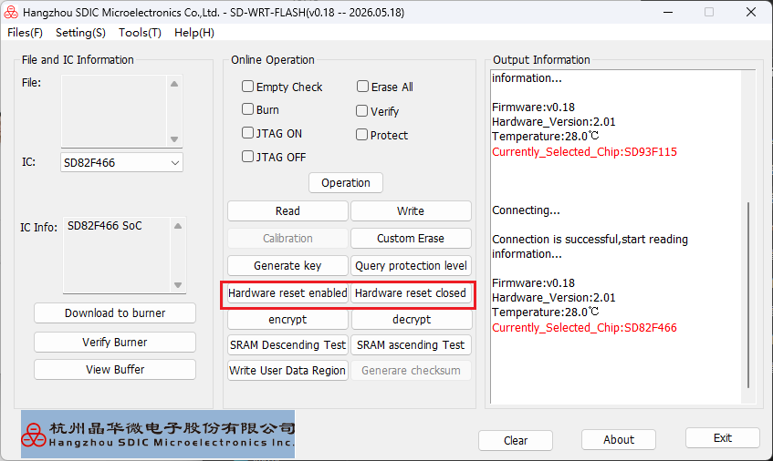
Figure 4.8.1 SD82F46X Online Hardware Reset

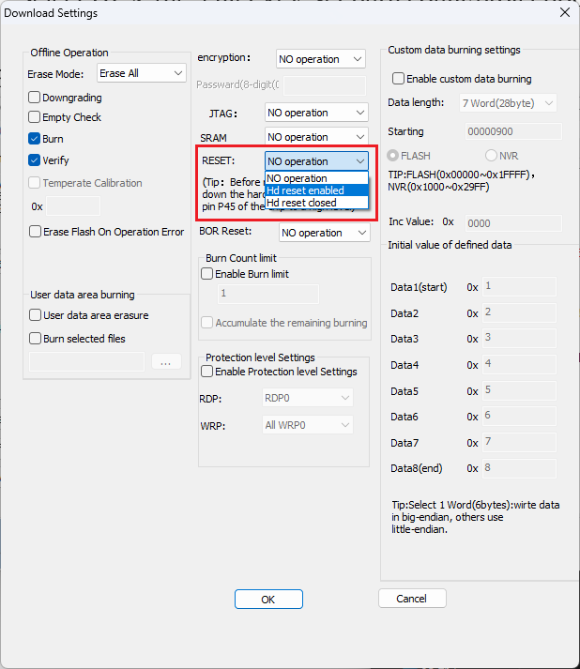
Figure 4.8.1 SD82F46X Offline Hardware Reset

  - SRAM Test
The SD82F46X chip supports ascending, descending and full-sequence tests to verify the normal operation of the chip storage area. Perform ascending, descending or full-sequence tests by executing corresponding operations as shown in Figure 4.9.1 and Figure 4.9.2. If any error occurs, the address of the first faulty storage space will be displayed.
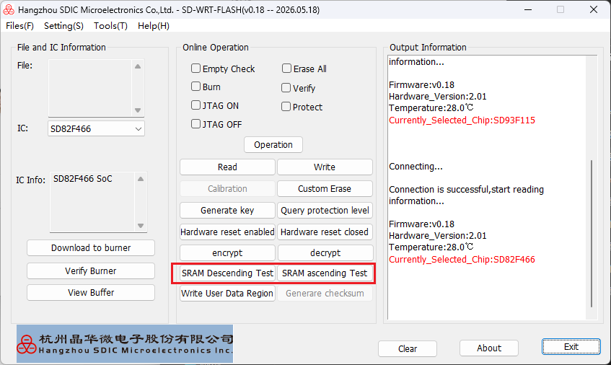
Figure 4.9.1 SD82F46X Online SRAM Test

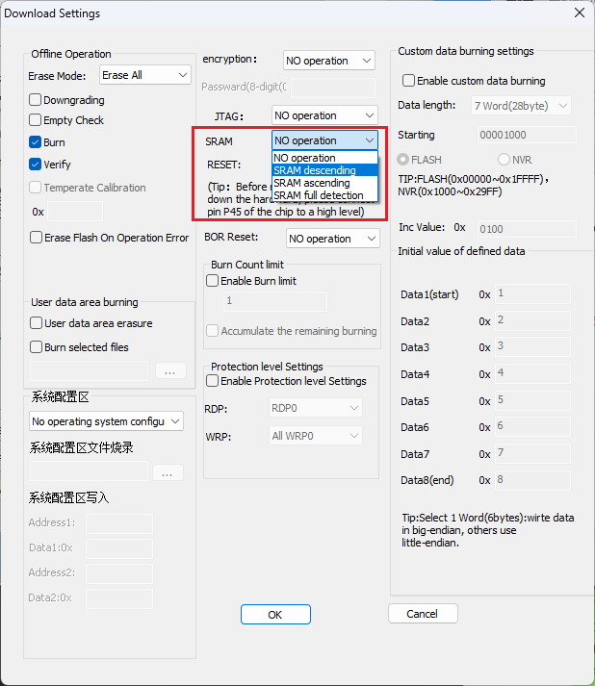
Figure 4.9.2 SD82F46X Offline SRAM Test

  - Factory Account
The factory account username is “factory” and the password is “yinxing”, as shown in Figure 4.10.1. After logging in to this account, there will be no further update prompts for the upper computer software and lower computer firmware. Upgrades of the programmer software and firmware are unavailable under this account. Switch to a regular account if you need to perform updates.
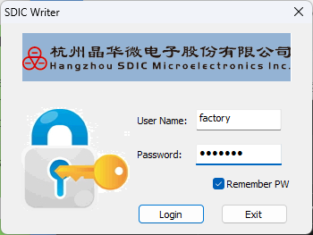
Figure 4.10.1 Production Account

  - Configuration File Account
The configuration file account is “SDIC_INI” with the password “yinxing”. Under this account, developers can configure HEX or IHEX files to generate SDIC files. Such files cannot be viewed by any tools and can only be directly imported into the programmer for burning. It enables the production department to quickly import SDIC files and effectively avoid file import errors.

  - Offline Operation
Click the “Download to Burner” button to pop up the “Download Settings” dialog box, taking SD93F115B as shown in Figure 4.12.1. Complete required function configurations and download them into the programmer. The user program and configured operations will be saved inside the programmer. You can directly press the Start key on the programmer to execute operations without connecting to the PC software.
The offline operation interface for SD82F46X series chips is shown in Figure 4.12.2, for SD93F302/SD81F233 series chips is shown in Figure 4.12.3, and that for SD25FXXX series chips is shown in Figure 4.12.4. The displayed functions on offline programming interfaces vary among different chip models. Refer to the corresponding sections for relevant function descriptions.
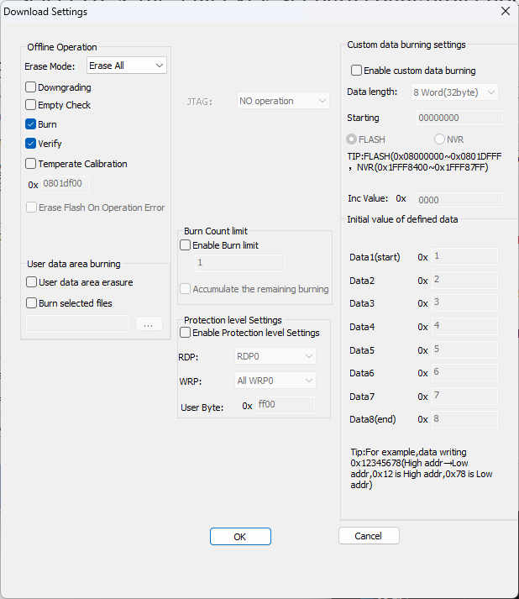
Figure 4.12.1 Offline burn setup (SD93F115 chips)

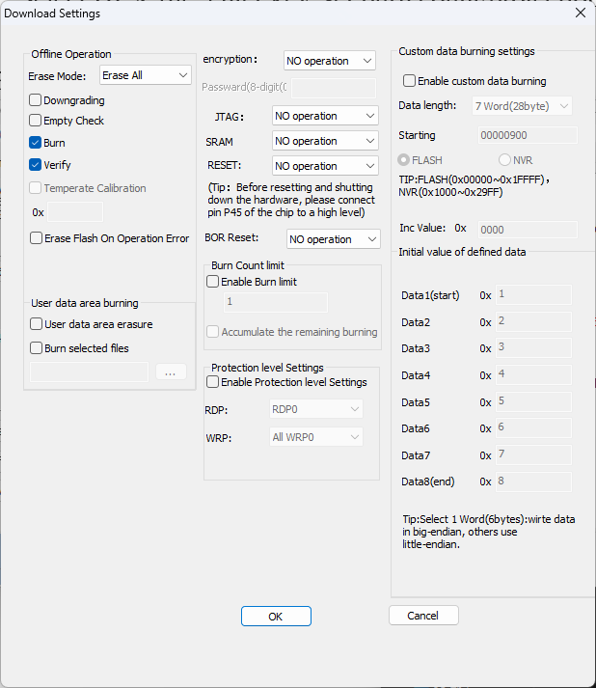
Figure 4.12.2 Offline burn setup (SD82F46X chips)

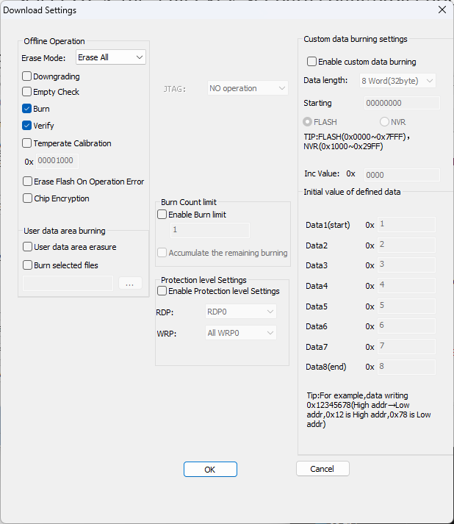
Figure 4.12.3 Offline burn setup (SD93F302、SD81F233chips)

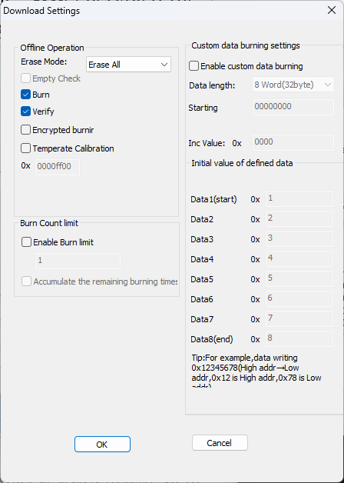
Figure 4.12.4 Offline burn setup (SD25FXXX chip)

SD93F302, SD82F46X, SD82F35X, SD82F255, SD82F479 and SD81F233 chips provide offline Flash erase and NVR erase options, as shown in Figure 4.8. 4.Flash erase is used to erase all user Flash area data. NVR erase can be freely selected to erase sector area in user configuration area and user data area. The sector area number to be erased can be written into the edit box and separated by ","(symbol format in English input state). Continuous sector area erase can be edited with (). Note that erasing user configuration area will change the protection level of the chip.SD82PX53 chip is an OTP chip and cannot be erased. Other operations are the same. For details, see the chip application manual (chip user configuration area, user data area and user Flash area size. For details, please refer to the chip manual).
Chips including SD93F302, SD81F233, SD82F35X, SD82F46X, SD82F255, SD82F479 and SD25FXXX support offline custom erase, including Flash Erase and NVR Erase options. Flash Erase clears all data in the user Flash area, while NVR Erase allows selective erasure of specified sectors in the user data area. Enter target sector numbers in the edit box and separate them with commas.
SD82P253 and SD82P153 are OTP chips that cannot be erased, with all other functions remaining the same. Refer to the chip application manual for details. The capacities of user data area and user Flash area shall be subject to the official chip manual.
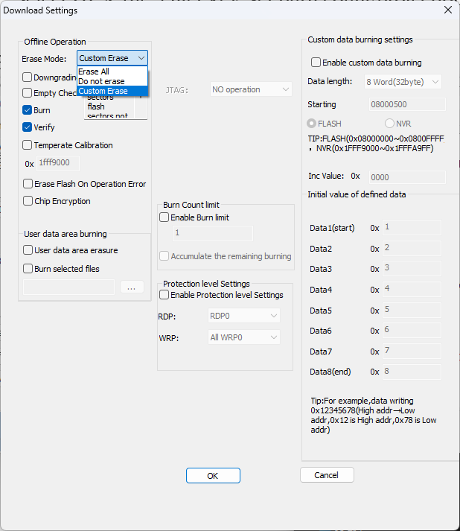
Figure 4.12.5 Offline Flash and NVR erase(SD93F302、SD81F233 chips)

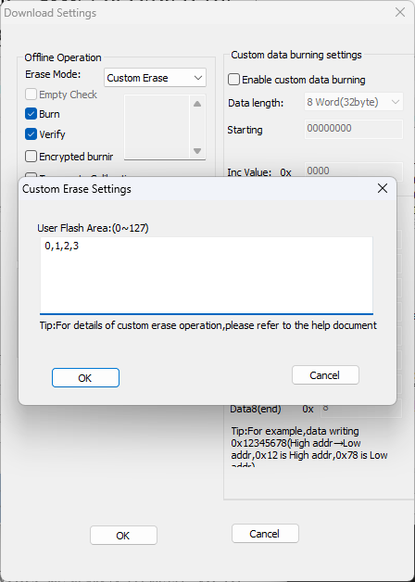
Figure 4.12.6 Offline custom erase (SD25FXXX series chip)

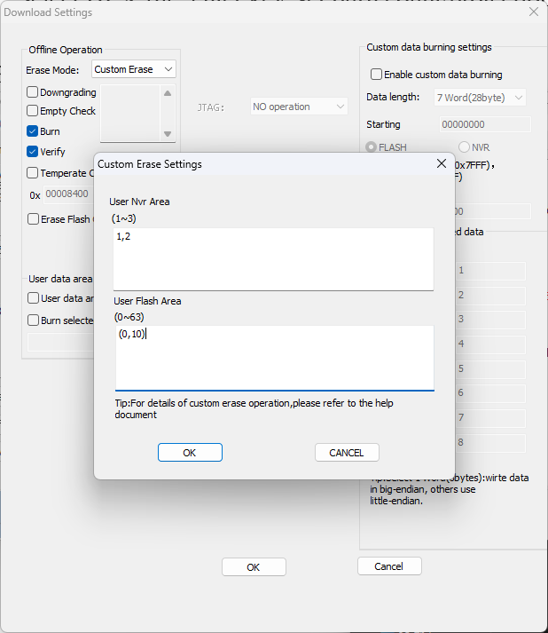
Figure 4.12.7 Offline custom erase (SD82F35X series chips)

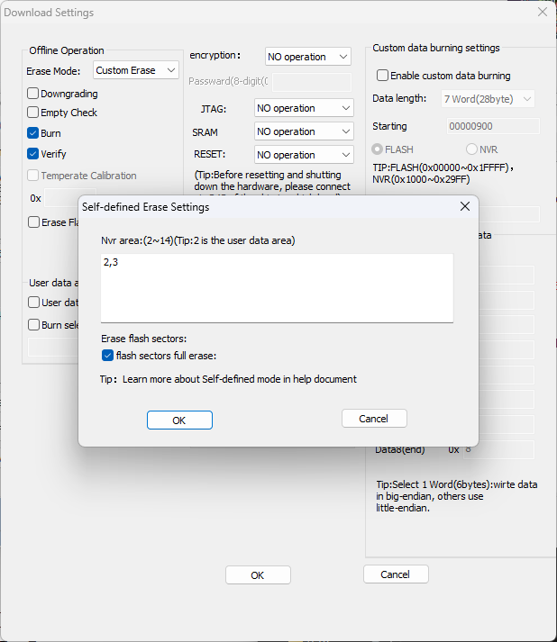
Figure 4.12.8 Offline custom erase (SD82F46X chip)

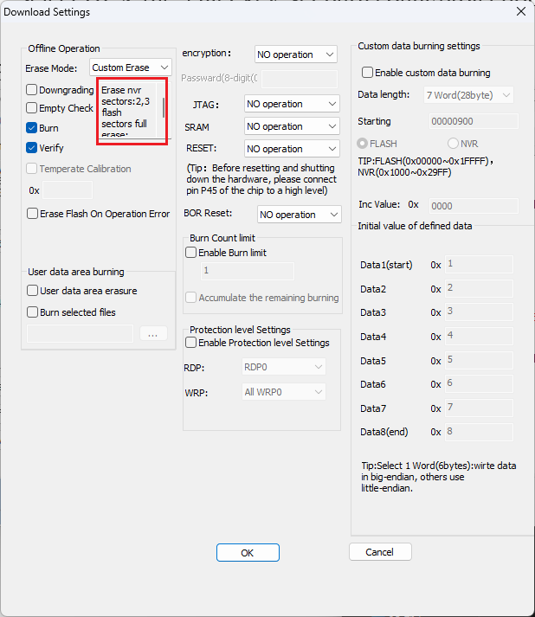
Figure 4.12.9 Offline custom erase (SD82F46X chip)

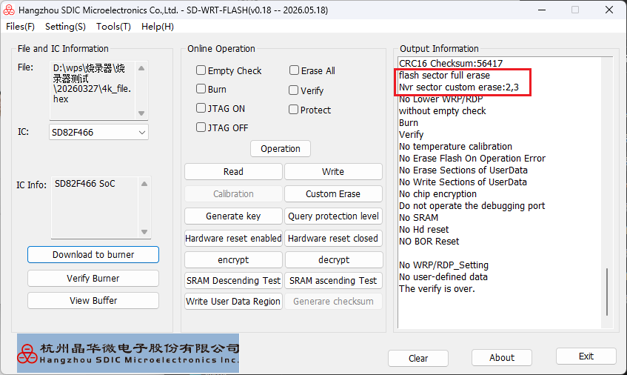
Figure 4.12.10 Offline custom erase (SD82F46X chip)

Erase Flash On Operation Error：This function is only available for chips such as SD93F302, SD81F233, SD82F46X, SD82F255, SD82F35X and SD82F479. When enabled, the Flash area will be automatically erased if the offline operation fails, as shown in Figure 4.12.11.
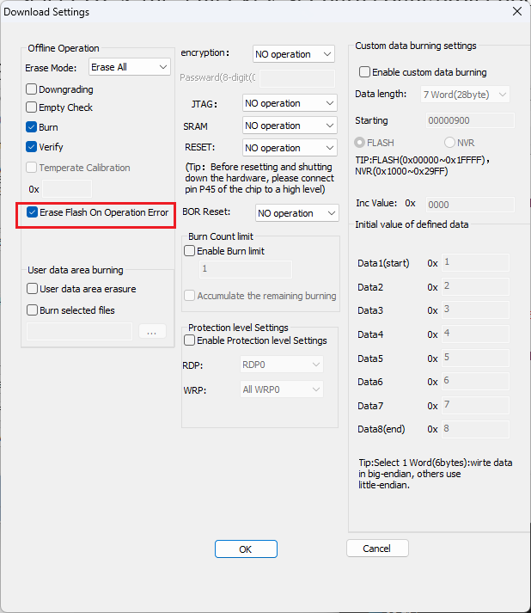
Figure 4.12.11 Erase Flash On Operation Error

  - Custom data burning
As shown in Figure 4.13.1, the data length of 1 word ~ 8 words can be selected for custom data burning. The starting address can be adjusted by itself. Note that it cannot exceed the size of the chip user program area or user data area. The step self-adding value can be selected. The self-adding is fixed as the 32-bit data self-adding at the end address. Custom initial values can be edited as needed.
SD93F112:
Flash: 0x08000000 ~ 0x0800DFFF NVR: 0x1FFF8400 ~ 0x1FFF87FF
SD93F115:
Flash: 0x08000000 ~ 0x0801DFFF NVR: 0x1FFF8400 ~ 0x1FFF87FF
SD93F115B:
Flash: 0x08000000 ~ 0x0801DFFF NVR: 0x1FFF8400 ~ 0x1FFF87FF
SD93F302:
Flash: 0x08000000 ~ 0x0800FFFF NVR: 0x1FFF9000 ~ 0x1FFFA9FF
SD81F233:
Flash: 0x0000 ~ 0x7FFF NVR: 0x1000 ~ 0x29FF
SD82F35X:
Flash: 0x0000 ~ 0x7FFF NVR: 0x8400 ~ 0x87FF
SD82F46X:
Flash: 0x0000 ~ 0x1FFFF NVR: 0x1000 ~ 0x29FF
SD25FXXX series chips only have Flash, no NVR.
SD82PX53:
Flash: 0x0000 ~ 0x3FFF, no NVR
SD82F255:
Flash: 0x0000 ~ 0x3FFF NVR: 0x80 ~ 0xBF
SD82F479:
Flash: 0x0000 ~ 0x1FFFF NVR: 0x1000 ~ 0x29FF
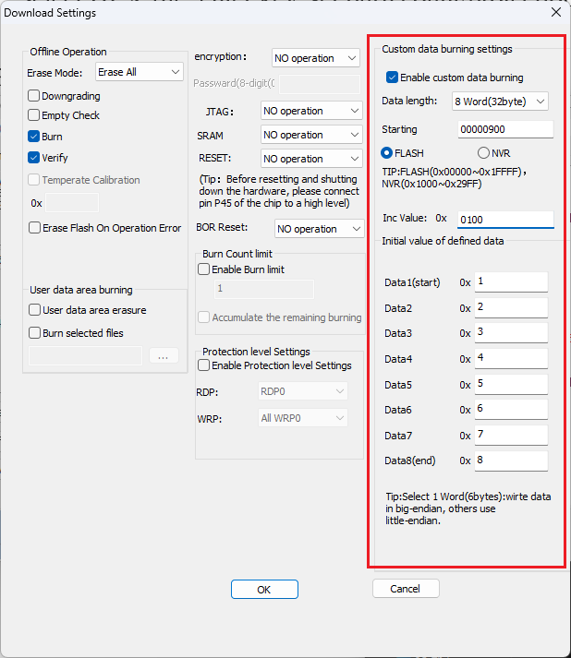
Figure 4.13.1 Custom Data Burning Settings

Chips including SD82F35X, SD82F46X and SD82PX53 support writing custom data of one word (6 bytes), which is mainly used for writing Bluetooth MAC addresses in big-endian mode, as shown in the figure.
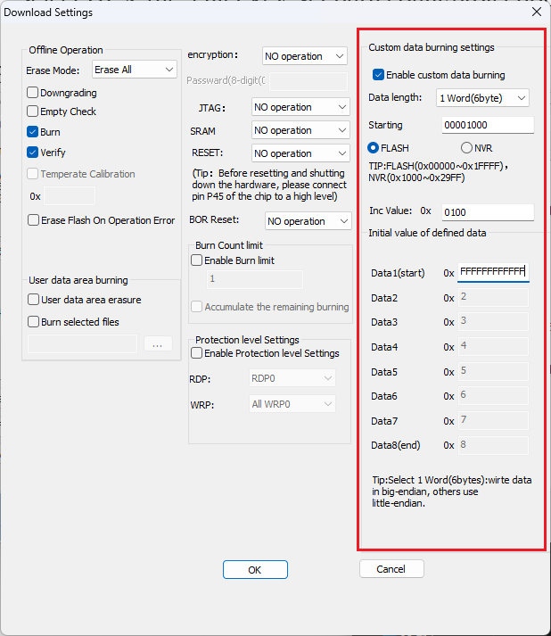
Figure 4.13.2 6-byte Custom Data Burning Settings

  - View custom data
Check offline download settings for custom data burning, custom data burning address, custom data.
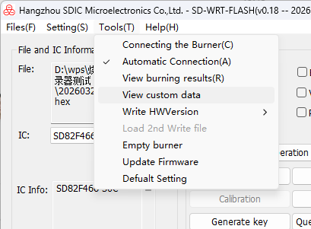
Figure 4.14.1 View custom data

  - NVR burning
Taking SD93F115 chip as an example, the NVR (0x1FFF8400 ~ 0x1FFF87FF) can be used to store user data, burner provides offline erase and burn function of NVR (please refer to chip manual for NVR of chip, subject to chip manual).
Select the "Download to burner" button to display the "Download Settings" dialog box, as shown in Figure 4.11.1. You can select the "User data area erasure" box and "Burn Selected Files" box as required. Burn files in the NVR can be imported by clicking the "..." button.
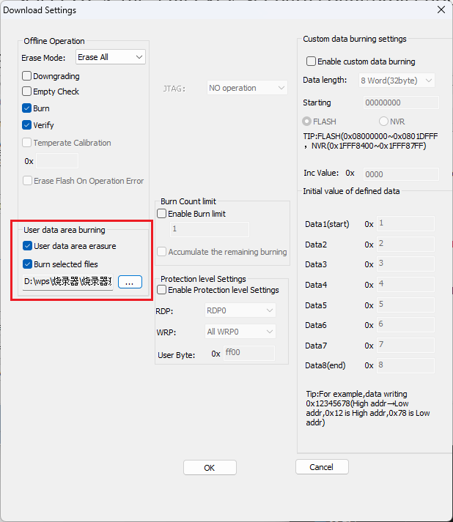
Figure 4.15.1 NVR Burning
The burn file format for the NVR is txt text. The format of writing burning data in text is shown in Figure 4.11.2. Write "the address of the lower 4 bits of burning address:16 bytes of burning data". The byte data address increases from left to right. The burning address data without writing text is written as 0xFF by default. It should be noted that the ":" after the burning address must be added and cannot be deleted, and the data after the "burning address: " must be 16 bytes, otherwise the burning data error may occur. In the Doc folder under the installation directory of the burner software, there are various burning file templates, as shown in Figure 4.11.6, users can fill in the data they want to write to the NVR (the difference between these two templates is that the byte size and starting address of the NVR are different, please refer to the chip manual for comparison).
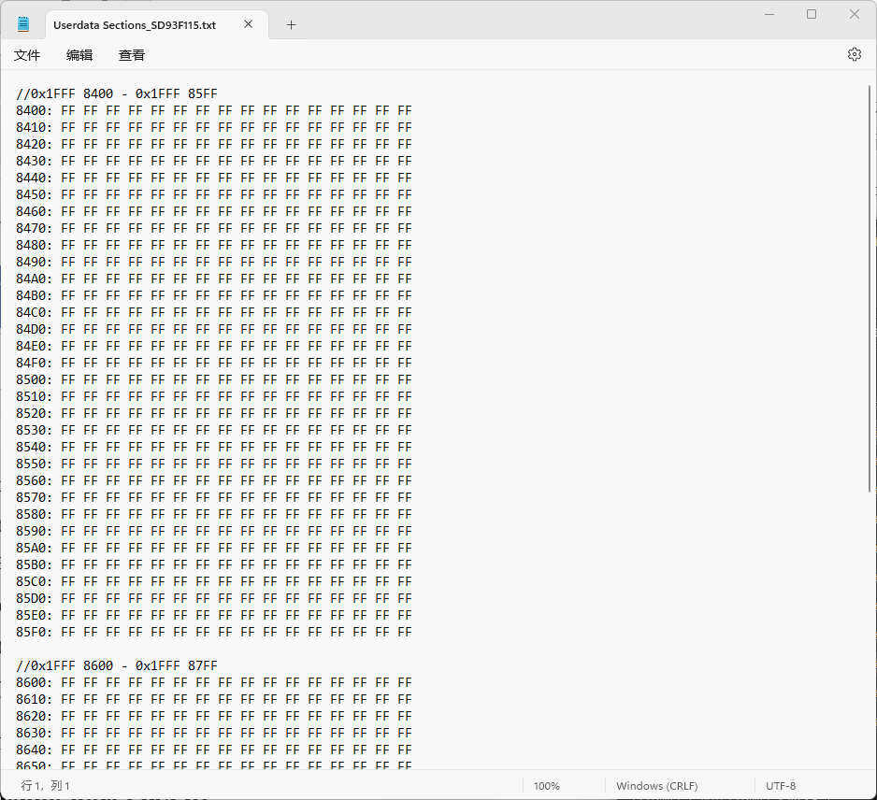
Figure 4.15.2 User Data Area Burning File Data Format (SD93F115, SD93F112, SD93F115B Templates)

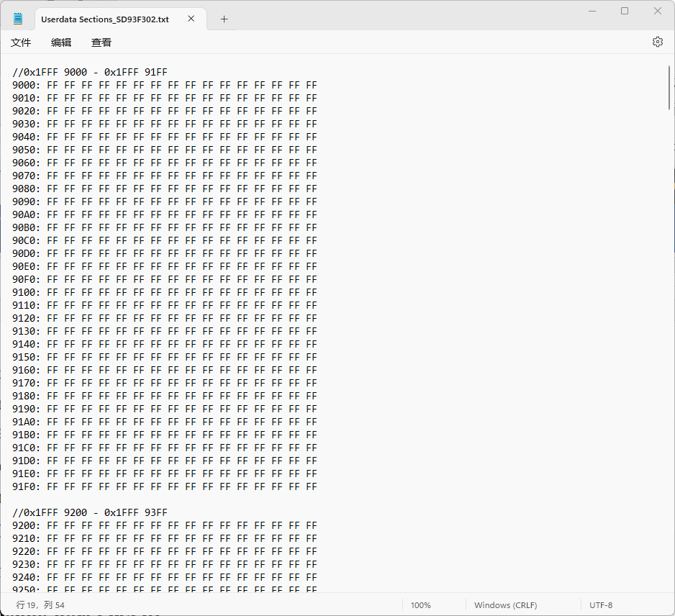
Figure 4.15.3 User Data Area Burning File Data Format (SD93F302 Template)

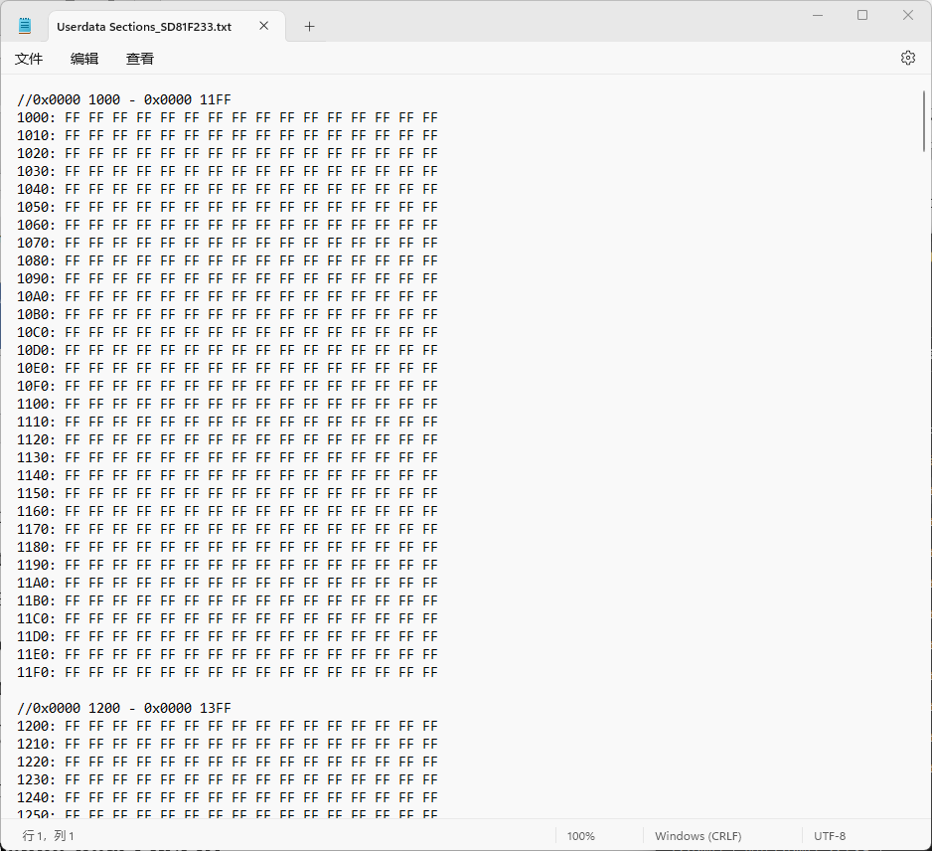
Figure 4.15.4 User Data Area Burn File Data Format (SD81F233 Template)

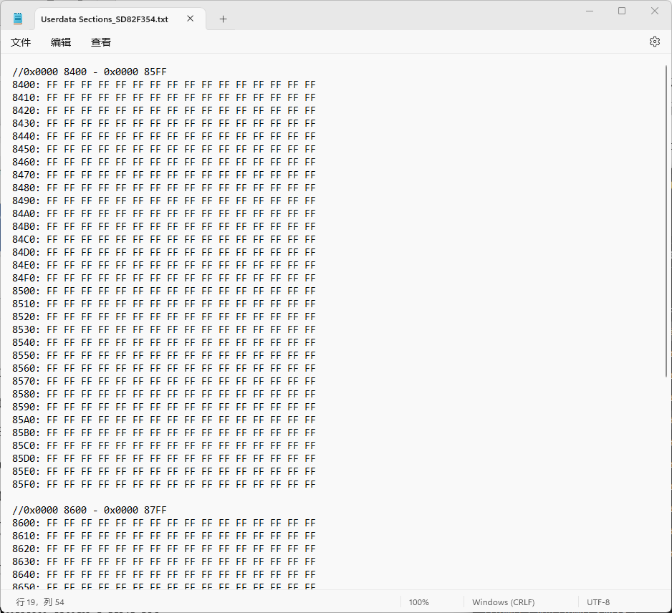
Figure 4.15.5 User Data Area Burn File Data Format (SD82F35X Template)

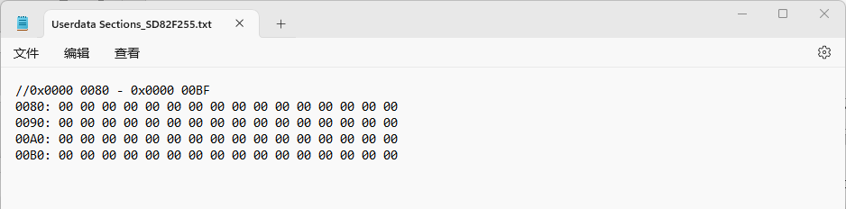
Figure 4.15.6 User Data Area Burn File Data Format (SD82F255Template)

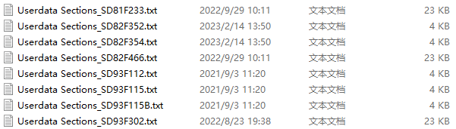
Figure 4.15.7 User data area burn file template

  - Offline temperature calibration
Offline temperature calibration is shown in Figure 4.16.1. After checking Temperature Calibration, the user can select the temperature calibration address to store the temperature and ADC value. Download the address of temperature calibration into the hexadecimal edit box, press the Start button, and the temperature value and ADC value measured by the burner will be stored in the temperature calibration address. The ADC value will be stored in the upper 16 bits of the temperature calibration address, and the temperature value will be stored in the lower 16 bits of the temperature calibration address. Offline temperature calibration Reference online temperature calibration function.
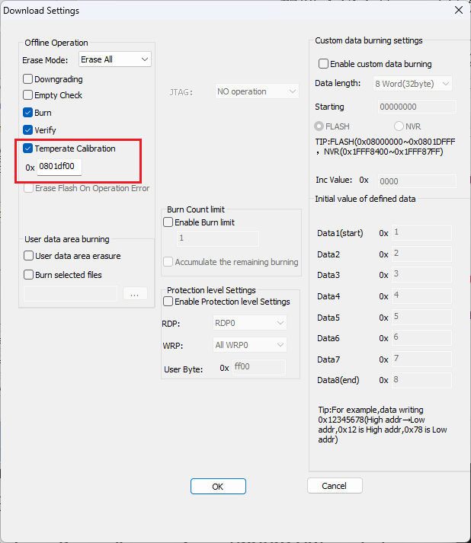
Figure 4.16.1 Offline temperature calibration

  - Verify burner
As shown in Figure 4.17.1, click "Verify Burner" to verify the data downloaded to burner, prompting the user whether there are errors to be changed, and the inconsistent places will be marked in red to remind the user.
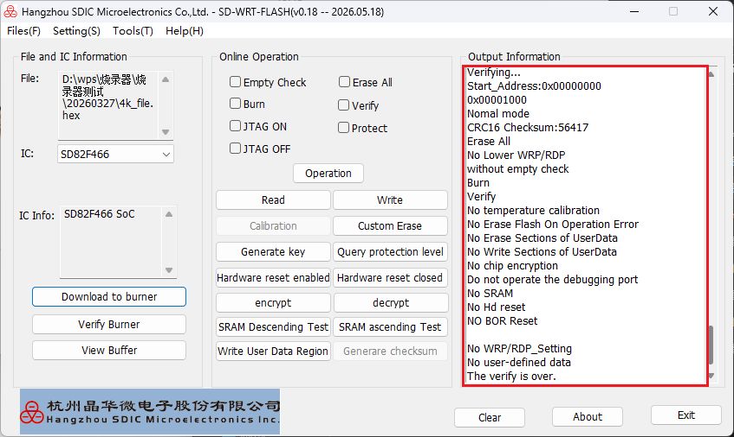
Figure 4.17.1 Verification burner prompt

  - Empty burner
It can clear offline burning programs downloaded into the burner.
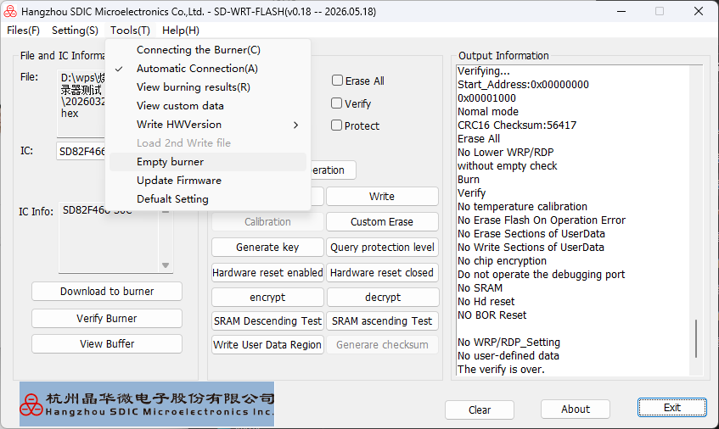
Figure 4.18.1 Empty burner

  - Hex file encryption
In order to limit the confidentiality and burning times of the program Hex file by the program developer, the program developer can encrypt the program, the number of times, etc. through the burner. The encrypted file performs algorithm encryption on the Hex file and records the information such as the burning times and the protection level. Once the program is decrypted and downloaded, the burning times and the protection level cannot be modified, and the encrypted file can only be decrypted once, thus ensuring the protection of the program Hex file and the limitation of the burning times. The process is shown in Figure 4.19.1.
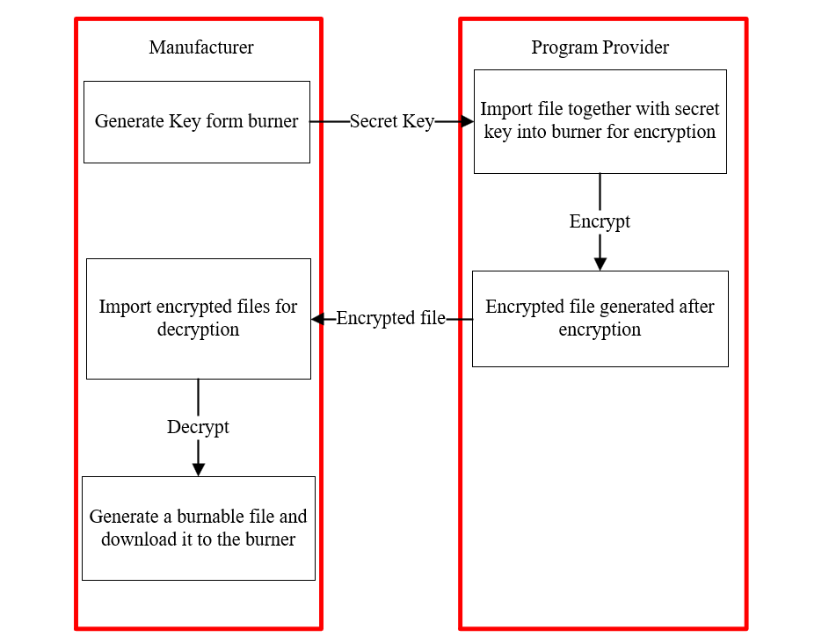
Figure 4.19.1 Encryption and decryption process

    - Key generation
The manufacturer opens the burner software and clicks the "Generate Key" button on the main interface to see the generated five-digit key in the output information box.
Do not close the software from key generation until decryption file creation is completed; otherwise the key will become invalid. Encrypted file generated with this key cannot be decrypted, and you need to regenerate the key and notify the program provider to re-perform encryption.
If multiple keys are generated consecutively, only the latest generated key takes effect.

    - Encryption
After the program provider obtains the key from the manufacturer, open the burner software, click "Encrypt files" under "File" in the menu bar, select the file to be encrypted, enter there levant settings and times in the pop-up dialog box as shown in Figure 4.19.2, and also enter the key. Click the encryption button to generate an encrypted file in SDF format, which can be decrypted by the manufacturer.
The program provider also needs to provide the program check code before encryption, which is convenient for the manufacturer to compare after decryption.
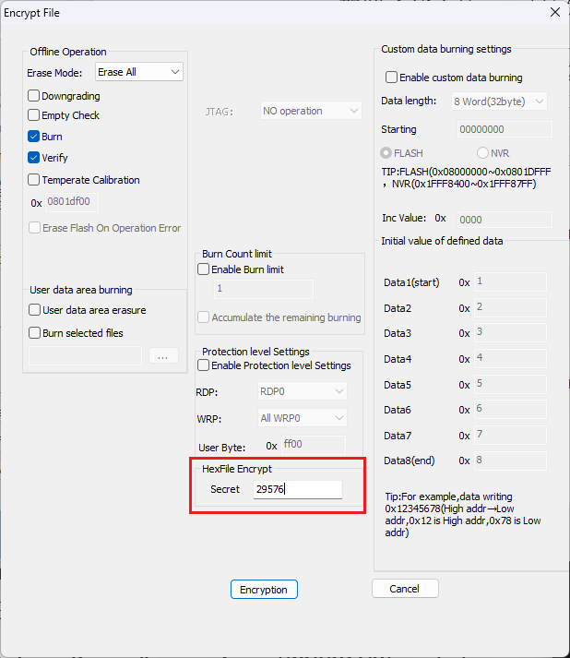
Figure 4.19.2 File Encryption

    - Decryption
The manufacturer gets the encrypted file from the program provider, clicks "Decrypt files" to import the encrypted file
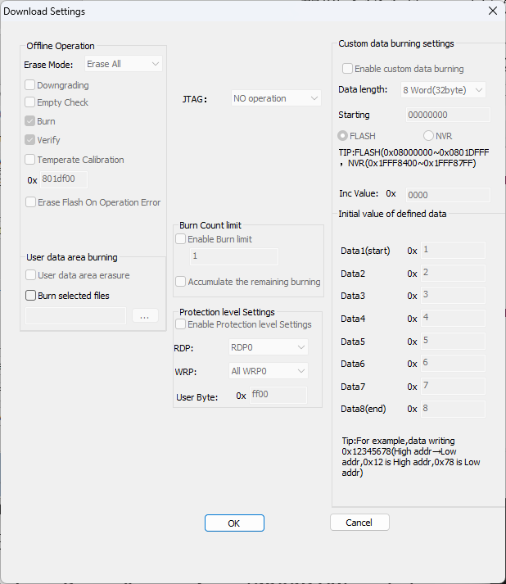
Figure 4.19.3 File decryption

  - Debug port operation
The SD82F46X and SD82F255 supports enabling and disabling debug ports in both online and offline modes. Enabling the debug port activates the corresponding chip debug functions, while disabling it turns these functions off.
For online operation, select either enable or disable mode, then click the operation button as shown in Figure 4.20.1. In offline mode, the debug port remains unchanged by default. Users may adjust the debug port status as needed, and the relevant offline settings are displayed in Figure 4.20.2.
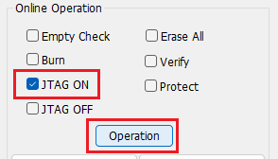
Figure 4.20.1 Online debugging port operation

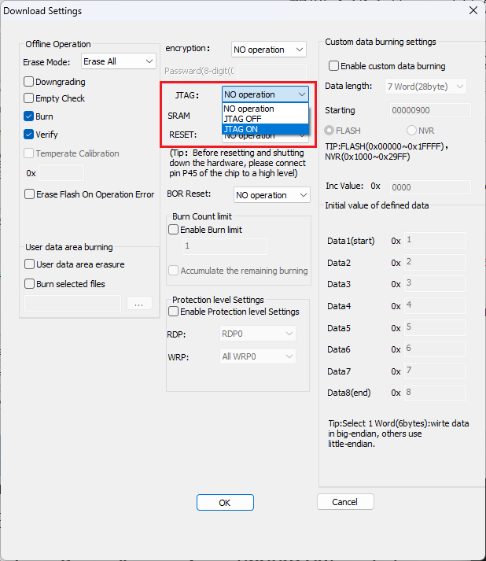
Figure 4.19.2 Offline debugging port operation

  - Chip Encryption and Decryption
SD82F46X, SD82F255 and SD82F479 support custom password-based encryption and decryption. The password consists of 8 digits ranging from 0 to 9, as shown in Figure 4.21.1 and Figure 4.21.2. Click the chip encryption button and enter the password in the pop-up window to encrypt the chip. An encrypted chip can only be operated normally after being decrypted by entering the correct password via the decryption button.
A new Decrypt + Encrypt function is added. Regardless of whether the chip is password-protected or not, enabling this option will encrypt the chip after execution. If the chip already has an existing password, the password entered for this function must match the original one.
For SD82PX53, SD81F233 and SD93F302, encryption is enabled by checking the protection option on the online operation interface or the chip encryption option on the offline interface, as shown in Figure 4.21.3 and Figure 4.21.4. Chips of these models cannot be decrypted after encryption, so please operate with caution. Refer to the chip application manual for full details.
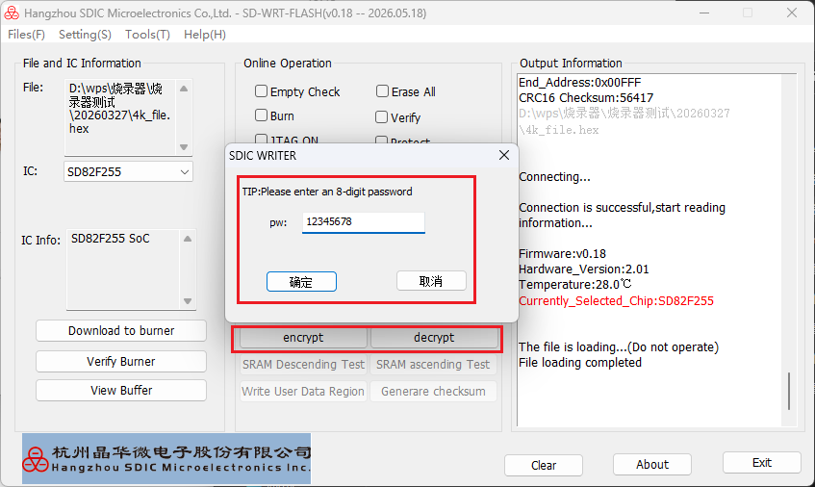
Figure 4.21.1 Chip encryption and decryption

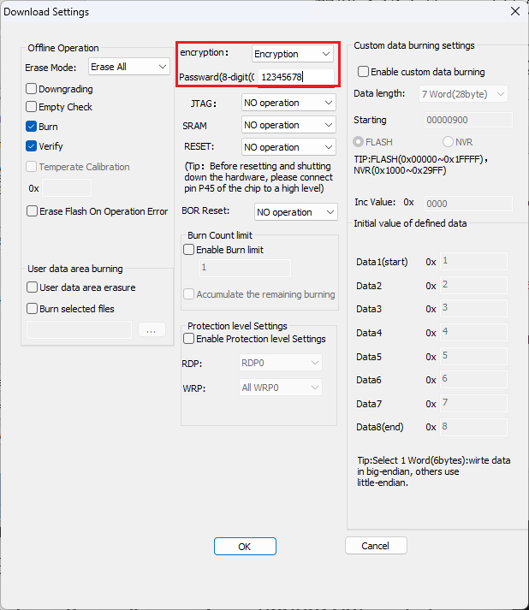
Figure 4.21.2 SD82F46X、SD82F255、SD82F479 offline encryption and decryption

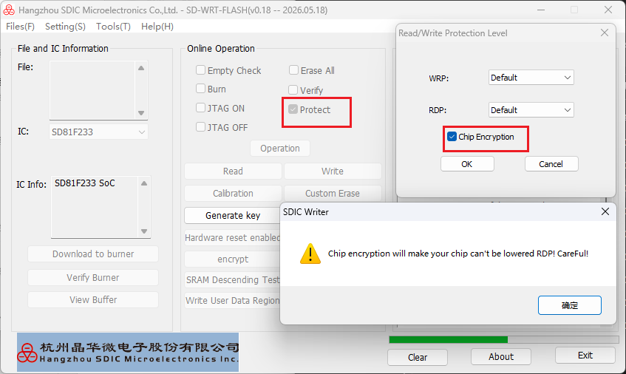
Figure 4.21.3 SD82PX53、SD81F233、SD93F302 online encryption

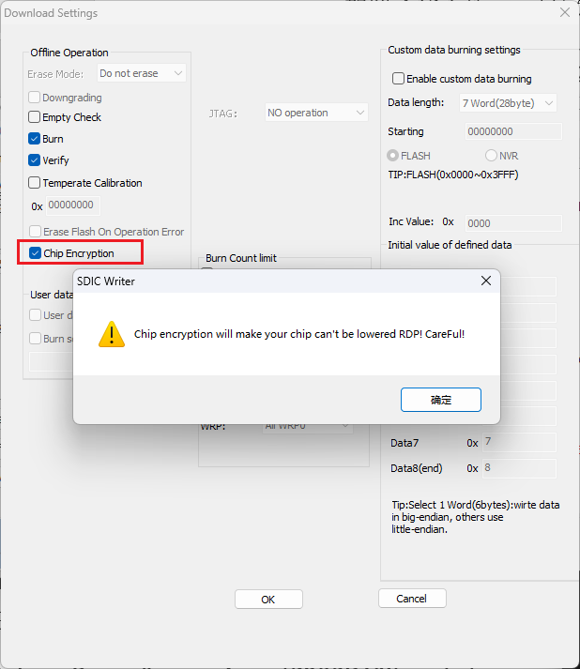
Figure 4.21.3 SD82PX53、SD81F233、SD93F302 offline encryption

  - Voice Files
The SD82F479 chip is equipped with a 256K voice data area and a 128K code data area. After selecting the SD82F479 model, check the voice data area option to operate the voice data area; otherwise, the code data area will be operated by default.
Click the button next to Code File to import code files, or import local code files via the File option in the menu bar. Click the button next to Audio File to import voice files.
Port Code means connecting the programmer’s programming port to the chip’s CODE port; Port Data means connecting the programmer’s programming port to the chip’s Data port to perform operations on the voice data area, as shown in Figure 4.22.1.
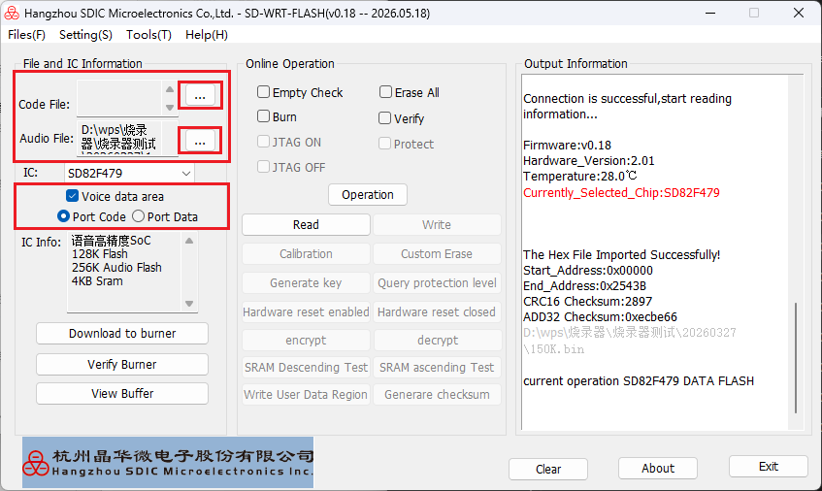
Figure 4.22.1 Voice data area operation
The voice data area of SD82F479 can also be downloaded to the programmer for offline operation, as shown in Figure 4.22.2. After importing the voice file, check the voice data area operation option and click Download to Programmer to complete the corresponding configuration.
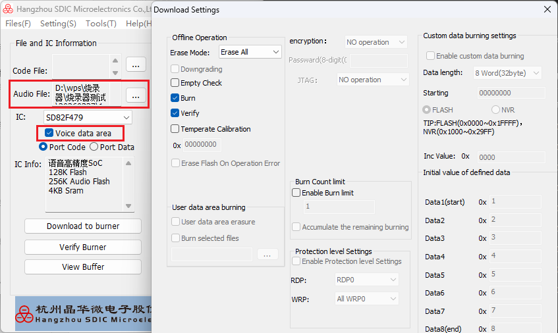
Figure 4.22.2 offline voice data area operation
  - Live Power Programming
The SD82F46X supports two methods for live power programming.
Method 1: Control via Special Program
Procedure: In the SD82F46X firmware, check if the pin connected to the programmer is at a low level. If low, configure the system clock to 32K and execute the library function RCC_ISP_SOFTRST.
Working Principle:
- Before performing live power programming, connect the BIN pin of the programmer to the ISP reset pin of the SD82F46X (defined in the firmware to receive the programming signal).
- In the firmware, configure the ISP reset pin of the SD82F46X as input with pull-up.
- Before executing the ISP operation, the programmer pulls the BIN pin low to enable the ISP reset.
- The SD82F46X reduces the system frequency to 32K within the interrupt service routine and then executes RCC_ISP_SOFTRST.
- The programmer initiates the ISP connection and performs ISP operations after a successful connection.
- After the operations are completed, an ISP exit is executed. The CPU (SD82F46X) is then released from reset and resumes normal operation.
Method 2: Enable Hardware Reset via Host Software
Procedure: First, connect the T3 pin of the burner to the P45 pin of the chip. Then enable the hardware reset function to perform live power operations on the chip.

  - Online User Data Area Programming
The SD82F46X supports online programming of the user data area, with identical operating steps to offline programming. Simply import TXT files formatted in the specified standard to complete programming, as shown in the figure below.
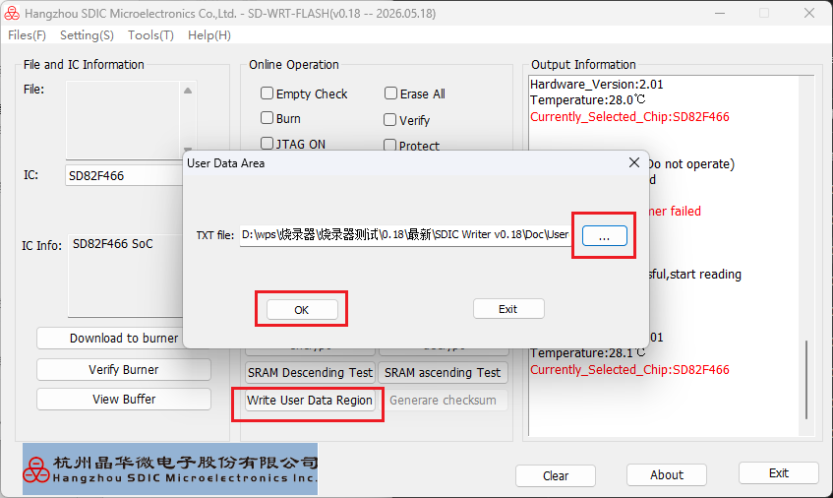
Figure 4.24.1 SD82F46X write user data region

- Mass Programmer's Signal
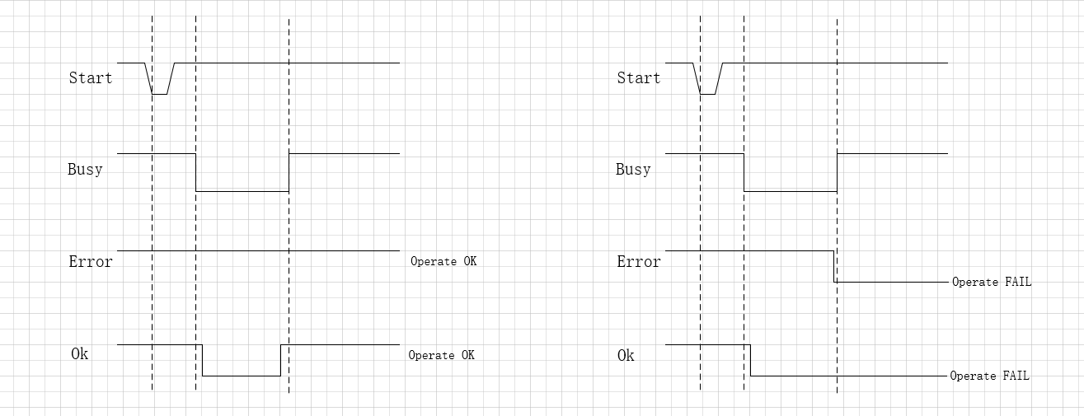
Figure 5.1 Timing Diagram of Programmer Control Signals

- Error prompt
If an error occurs during the use of the burner, an error code will be displayed on the digital tube. The error code is described as follows:
Error Code | Description
CERR0 | program verification error
PERR0 | program burning error
PERR1 | Custom data burning error
PERR2 | Communication error between burner and chip
PERR3 | Error in protection level setting
PERR4 | User byte burning error
PERR5 | Erasure error
PERR6 | Ciphering error
PERR7 | Chip has existing data; cannot program
TERR1 | Temperature calibration count exceeded
TERR2 | Communication error during calibration
TERR3 | Temperature calibration error
TERR4 | Calibration write error
TERR5 | Calibration address out of range
EEERR | Burn count save error

- FAQ
  - Driver Installation
If the SDIC driver is not recognized or used after installation, restart the computer once before using it.

- Modified record
version number | prepared by | modification date | modified record
v0 |  | 2021-05-14 | initial version
v0.01 |  | 2021-07-23 | Added Hex file encryption function description
v0.02 |  | 2021-09-03 | Added description of burning function in user data area; modified partial description and screenshot
v0.03 | Xu Siyu | 2022-07-26 | Add SD93 F302, SD25 FXXX chip operating instructions
v0.04 | Xu Siyu | 2022-11-09 | Add SD81 F233, SD93 F115B chip instructions
v0.05 | Xu Siyu | 2023-02-17 | Added SD82F354 chip description
v0.06 | Yang Fujin  and  Ji Qihui | 2023-05-09 | Added error description of PERr6, description of HEX/IHEX file imported from different chips, description of main interface operation.
v0.07 | Ji Qihui | 2023-06-29 | Add SD25FXXX series chip, SD82F354 chip offline custom erase instructions
v0.08 | Ji Qihui | 2023-09-22 | Add SD93F302 chip, SD81F233 chip offline FLASH erase and NVR sector erase instructions, the original SD82F354 chip modified to SD82F35X series chip
v0.09 | Yang Fujin | 2023-12-07 | Added SD82F466 chip description
v0.10 | Yang Fujin | 2024-05-16 | Add SD82P253 chip description, add burner automatically update import local files some description, Hex file encryption and decryption burner can be closed description.
v0.11 | Yang Fujin | 2024-08-26 | Added SD82P153 chips
v0.12 | Yang Fujin | 2024-12-11 | Add instructions for the SD82F46X chip debugging port operation
v0.13 | Yang Fujin | 2025-02-17 | Add hardware interface instructions for live burning of SD93f115B and SD82F46X chips
v0.14 | Yang Fujin | 2025-05-14 | Add SD82F465 chip, SD82F46X chip hardware reset, SRAM detection, chip encryption and decryption, erase Flash function after offline operation errors, and add instructions for using production accounts
v0.15 | Yang Fujin | 2025-05-28 | Add error explanation for PERR7
v0.16 | Yang Fujin | 2025-07-02 | Added SD82F255、SD82F479 chips
v0.17 | Yang Fujin | 2025-12-29 | 1. Add online programming for the user data area of SD82F46X chip  2. Add custom data programming function for SD82PX53 and SD82F255 chips  3. Fix the address description of the NVR area of SD82F46X chip  4. Add offline decryption function for SD82F46X, SD82F479 and SD82F255 chips  5. Add temperature calibration function for SD82P253 chip  6. Support encryption, post-encryption verification and checksum reading functions for SD82PX53 chip  7. Optimize the checksum reading function of SD82PX53 chip  8. Fix the bug that 32 blocks still show write-protected after unchecking and canceling custom write protection level in offline settings  9. Extend the range of offline custom data step value up to 0xFFFF  10.Add 6-byte custom data writing function for SD82F46X and SD82F35X chips
v0.18 | Wu Peisi | 2026-05-18 | 1. Add new account SDIC_ini for generating configuration files  2. Rectify inaccurate descriptions of several functions  3. Add the introduction of the Decrypt + Encrypt function for SD82F46X, SD82F255 and SD82F479 chips in Chapter 4.21

